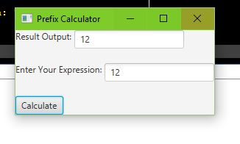

Capture of what happens if user inputs 12.

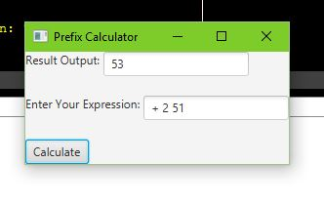

Capture of what happens if user enters + 2 51

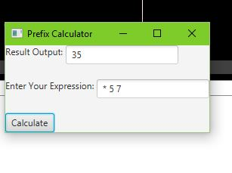

Capture of what happens if user enters \* 5 7

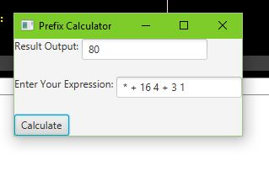

Capture of what happens if user enters \* + 16 4 + 3 1